**Alekhya Krishna Balivada Python Day 5 Assessment-5(16-12-2023)**

**Lambda Function:** If we don’t give name to the function then it is known as ‘Anonymous Function’ also known as ‘LAMBDA’.

**Lambda Filter( ), Map( ) , Reduce( ) :**

Filter( ) **:**It filters data.

Map( ): If we want to change any value we use map( ).

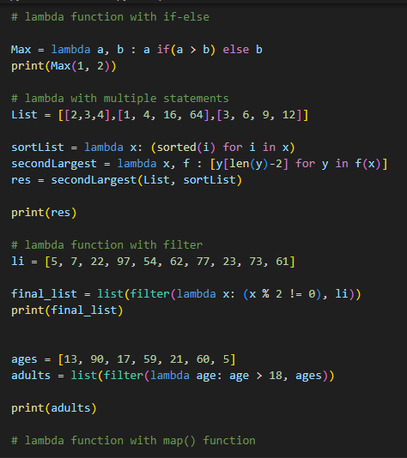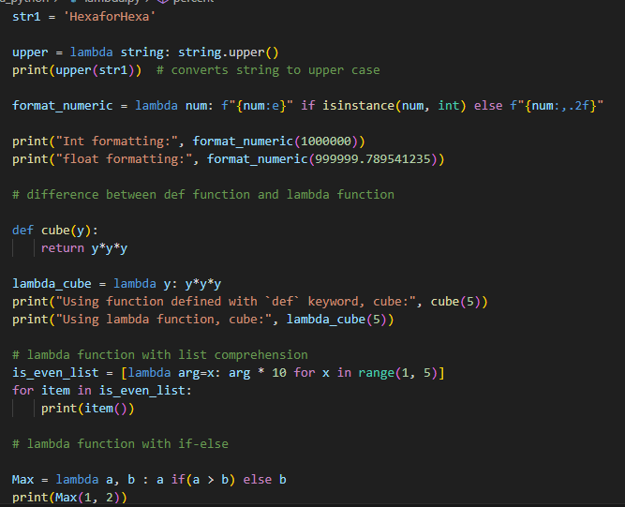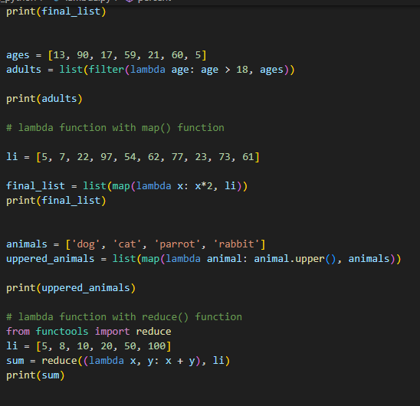Reduce( ): It is useful for performing some computation on the list.

**Pass by Value & Pass by reference:**

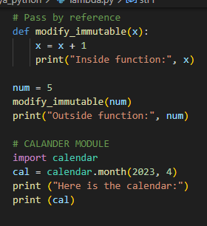

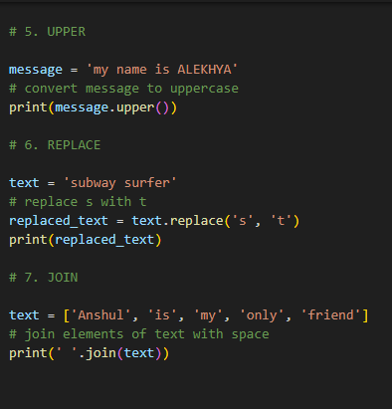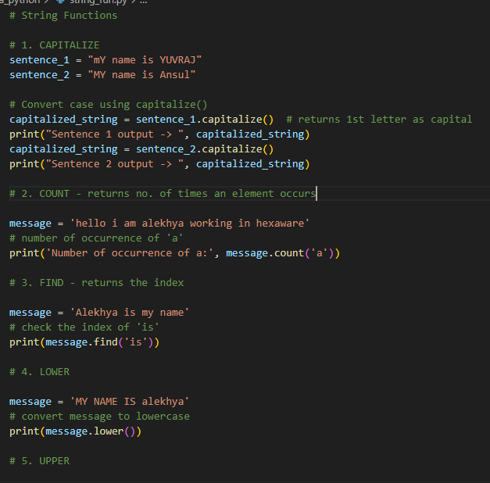**String Functions:**